# Proto FusionGirl - Game Timeline

## The Fusion Girl Saga - **Solar Cycle 26** *(2032-2044)*

#### **Proto Fusion Girl - (2032-2036)**

#### Fusion Girl - *(2036-2040)*

#### Final Fusion Girl - *(2040-2044)*

### **Tech Timeline**

Solar Cycle 25 = Spacer Tech (2020-to-2032)  
**Solar Cycle 26** = Star Tech (2032-to-2044) - **Fusion Girl Saga**

* **Phase 1** (2032-2036) - **Proto Fusion Girl**: Jump from **Holo Tech** to **Fusion Tech**
* Phase 2 (2036-2040) - Fusion Girl: Jump from **Fusion Tech** to **Star Tech**
* Phase 3 (2040-2044) - Final Fusion Girl: Jump from **Star Tech** to **Warp Tech**

Solar Cycle 27 = Hyper Tech+ (2044-to-2056)

## Psionic Timestream Storyline Generator

FusionGirl and all of the Natura games use a **Psionic Timestream Storyline Generator**.

* Timestreams enable a natural progression of automated storytelling
* Timestreams can be dynamically generated in real time or precalculated
* Timestreams are already generated for the entire video game timeline

# Psionic Timestream Storyline Generator

The Psonic Timestream Storyline Generator is an SDK framework that uses Timestreams for Procedurally Generated Storytelling in video games and future forecasting.

## Timestreams phases align with The Hero’s Journey

###### The 12 phases in a Timestream each correlate to a step in The Hero’s Journey

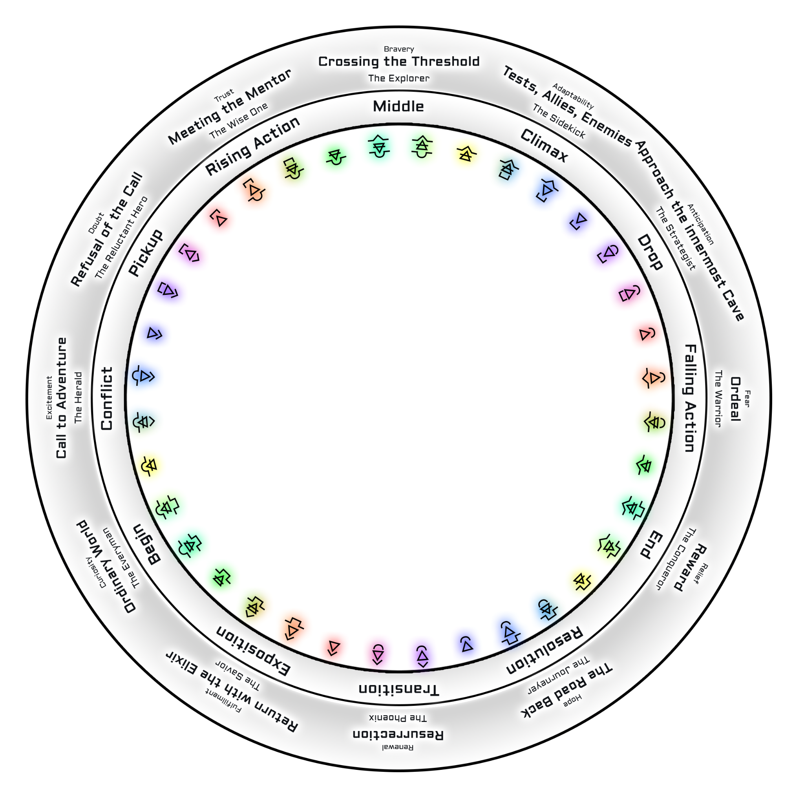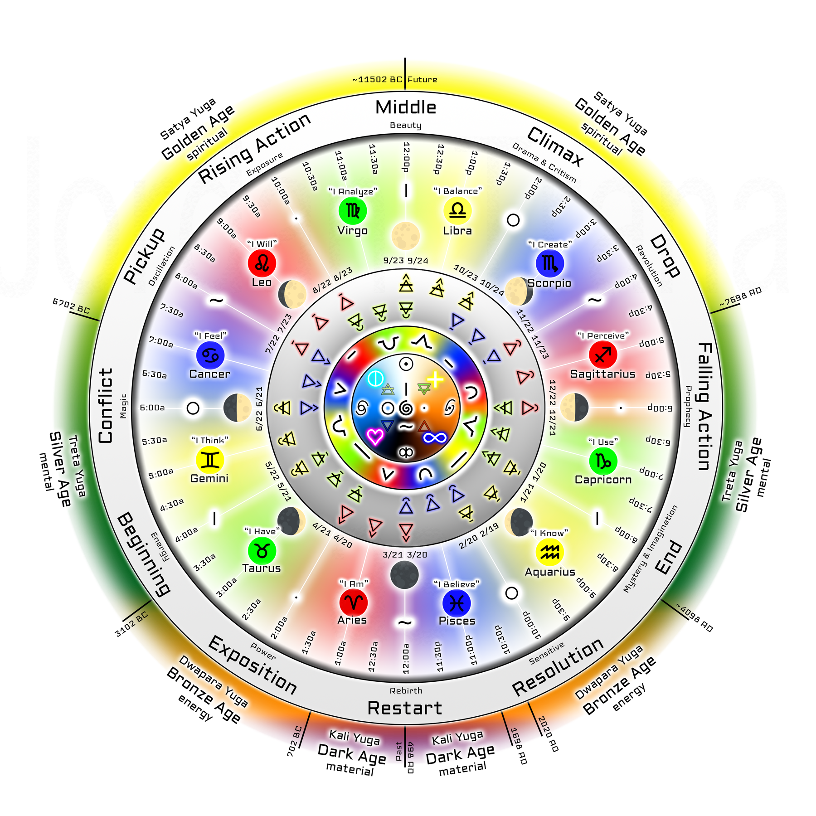

# Example: 2025 Time Map Planetary Harmonic Timestreams

* *Side Note: Special NFT Items can be collected like ‘Old Future Time Maps’*

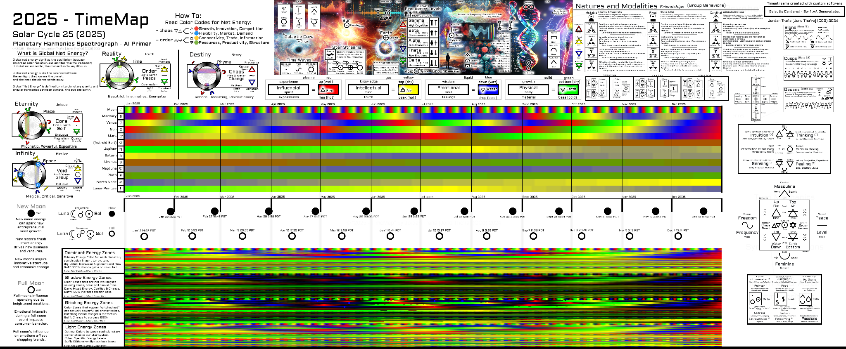

## **Timestreams**

### What are Timestreams?

Timestreams are color-coded images used for interplanetary harmonic spectrographs.

* **Timestreams are used by AI to predict the future.**
  + Temporally organized data; easy to combine with other datasets
  + Works entirely offline; no need for internet access
  + Naturally visual; easily used for graphic effects and tone setting

### Notes when developing storyline generators using Timestreams

##### Timestreams make the timeline of the game static, while also allowing changes

##### Timestreams can be from other star systems with different planet configurations

##### Timestreams from other versions of Earth with different planet positions are possible

##### Timestreams from other versions of Earth with matching planet positions are possible

##### Timestreams can be used with shaders and for advanced graphic visualizations

#### Applications of Timestreams in Video Game Development

Lunar and Solar Cycles can affect the Tides, Economy and Behaviors of NPCs

* Changes the phase of each Biome over the Seasons.
* Determines the general mood of each Faction and Geolocation.
* Triggers Events like News, Actions, Updates, Releases.

# Psionic TimeStream Image Generator

Software used to generate real **Timestream** images for the creation of **Time Maps**.

## Mark 3 - Version 1

The Mk3v1 Psionic TimeStream Image Generator is customizable and can be used to make any timestreams for the video game between the years 1978 to 2062.

## Psionic Timestream Image Generator

##### Generates a set of 1px tall PNG image strips

##### Each horizontal pixel represents 1 day

##### Each pixel is color-coded RGYB data into RGBA data.

##### Multiple render modes and support for new metrics

## <https://github.com/Jthora/PsionicTimestreamImageGenerator/>

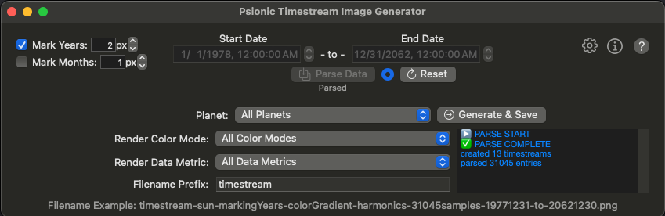

#### Rendered Timestream Example:

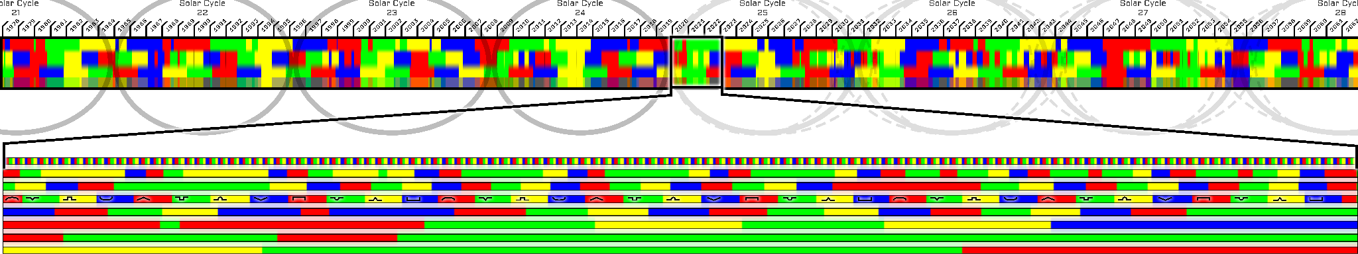

# The Hero’s Journey - 12 Steps (with Timestream Phases)

### Ordinary World **Begin**

###### The hero’s life before the adventure begins, offering a contrast to the extraordinary world they will enter.

### Call to Adventure **Conflict**

###### The hero is faced with a challenge, discovery, or event that propels them toward the unknown.

### Refusal of the Call **Pickup**

###### The hero initially hesitates or refuses the call due to fear, doubt, or obligation.

### Meeting the Mentor **Rising Action**

###### The hero encounters a guide or mentor who provides wisdom, tools, or encouragement for the journey ahead.

### Crossing the Threshold **Middle**

###### The hero leaves their ordinary world and enters the unfamiliar, extraordinary realm.

### Tests, Allies, and Enemies **Climax**

###### The hero faces challenges, meets friends, and identifies foes while learning the rules of the new world.

### Approach to the Inmost Cave **Drop**

###### The hero prepares for the central ordeal, confronting their deepest fears or greatest challenge.

### Ordeal **Falling Action**

###### The hero faces a major crisis or the most difficult challenge of the journey, often experiencing death or symbolic death and rebirth.

### Reward (Seizing the Sword) **End**

###### Having survived the ordeal, the hero claims the reward, which could be a treasure, knowledge, or newfound power.

### The Road Back **Resolution**

###### The hero begins their return journey to the ordinary world, often facing further challenges or tests.

### Resurrection **Transition**

###### The hero faces a final test or crisis, emerging transformed and prepared to apply their newfound knowledge.

### Return with the Elixir **Exposition**

###### The hero returns to the ordinary world with the “elixir”—a gift, lesson, or boon to share with others.